HOMEWORK
Indicaciones: Join according to the number that corresponds to the image.
Name:
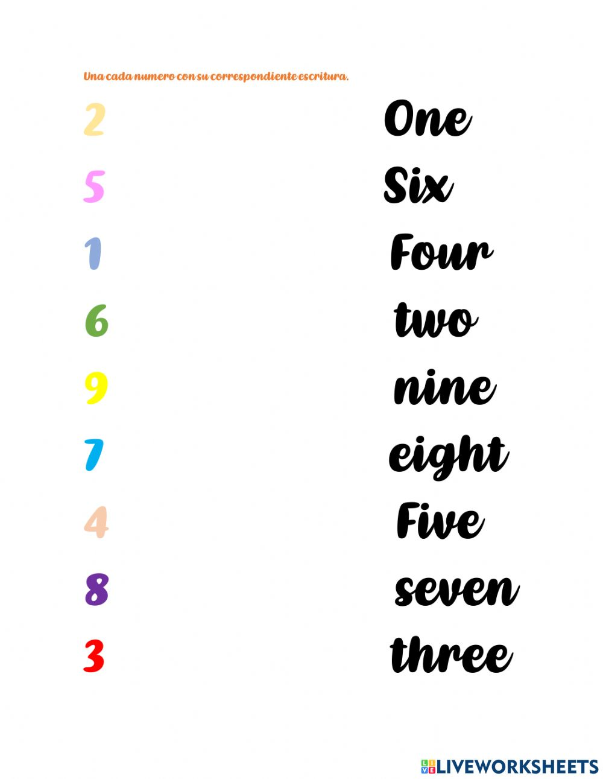
Grade:

