High School
Student’s name:
Couse:
Date:
Writing Presentation
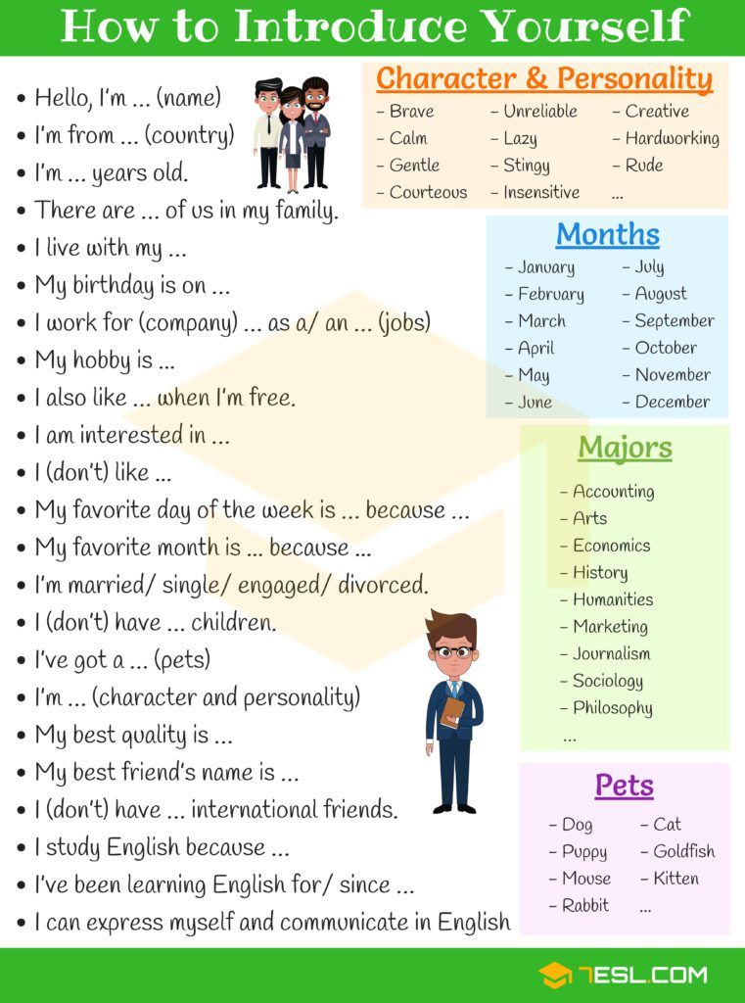

- Following the next example, write a presentation about your favorite person in the world. If you want you can add his/her best picture. (Write about 250 words)
The best person in the world is my brother. Her name is Mateo but people here call him Matt. He is 31 years old. I am very proud of him because all the time he stay with me. He grew up in Argentina, and he lived there most of his life before moving to the United States. He speaks Italian, Spanish and English. He loves gaming, and He streams on Twitch almost every day. He’s always wanted to improve his English so now that he has the time, he’s finally signed up for classes online. I love to spend time with him, because he makes me laugh a lot and I can forgot my stress…

