Homework
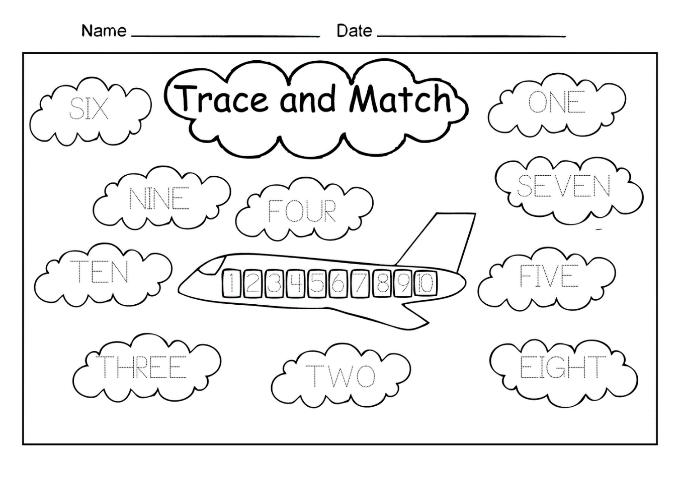
Trace the letters and match with the correct numbers

