Homework
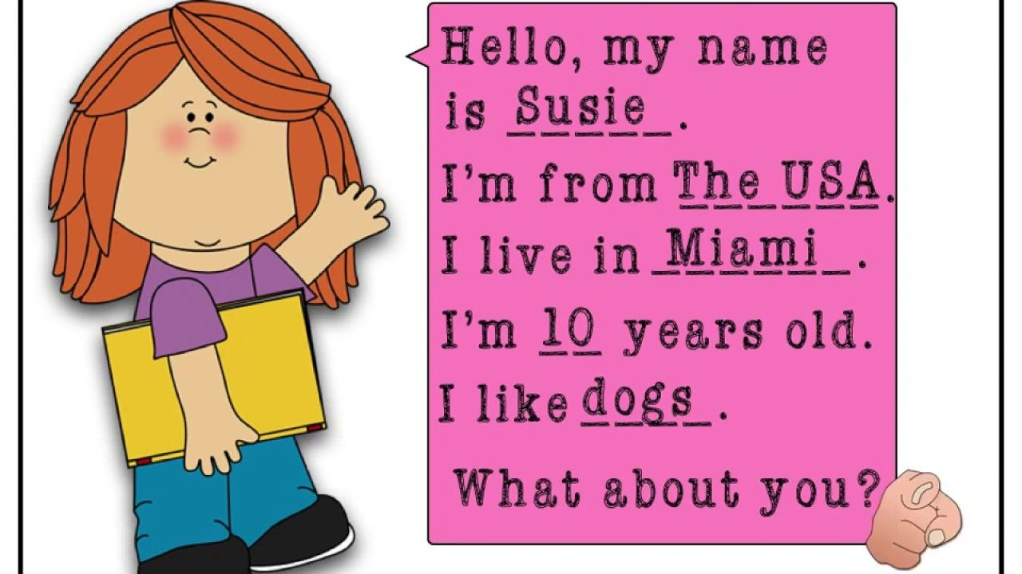
Draw a picture of yourself, then record a video while doing the personal presentation and show the picture you draw. Look at the example.

