A HISTORY LESSON – LERIDA, TOLIMA – PART II
Lerida as municipality has received names as: Coloya, Peladeros, Nuestra señora del Buen Suceso and Villa of Lérida, those names were given in different periods. We can’t deny that Spanish legacy is part of the identity in the America Nations, although the indigenous genocide and looting riches are part of our history.
The Panche are a community of fishers especially of catfish, craftsmen that controlled the fields in the high Magdalena, those fields are productives in agriculture and mining. They took the their name from a fish that is caught on the river and si called Bagre (catfish) but is more common the word “Panche”

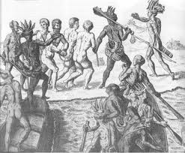

The Panche traditionally deformed the newborns’ skull, using small boards in front and behind the head.
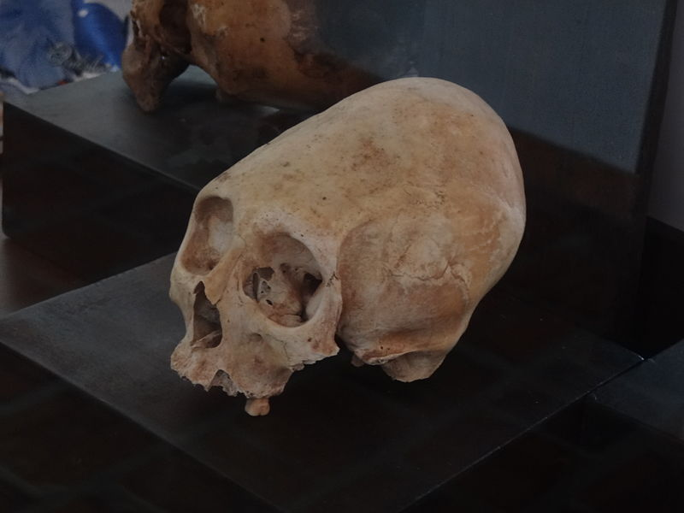
Cranial deformation
The governor of each tribe is chosen by shamans and old men in a group of dedicated, intelligent and brave men, the chief governs for life and the territory where his tribe lives took his name.
In the Panche dialect, when the words are split up, the prefix “Gua” appears. It means water and is used in words to baptize rivers like: Guali, Guarino, Guaguarco, Guatipore (Coello), Guandinosa, Guacacayo (Magdalena), Guanbeima (Combeima), Guacari (Gualanday), Guacolda among others.

