A HISTORY LESSON – LERIDA, TOLIMA – PART I

Before 1.492 It was Panche territory ruled by Siquima.
1.554, town of Indians of Coloya, ruled by Lope de Salcedo Jáuregui.
1.690 April 26th Coloya hamlet, Franciscan priests in fields of José Zabala.
1.777 church of Nuestra Señora del Buen Suceso of Peladeros, in the Mariquita province with Manuela Arciniegas and the viceroy Manuel Antonio Flores
1.863 Lerida, in the Tolima Department, with Antonio Dorjuela
1.991 Lerida Regional town, department of Tolima

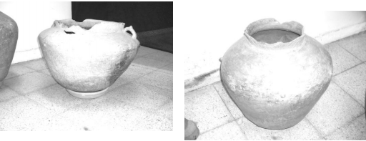
Indigenous pots in the Museum of Armero

RUINS OF COLOYA
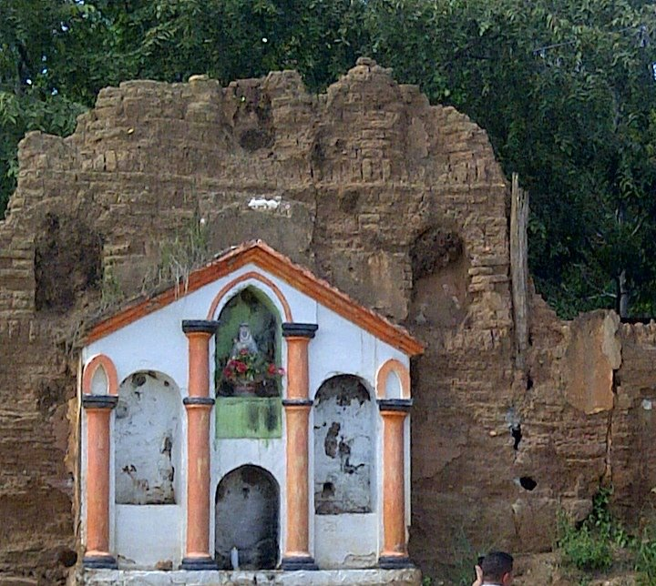

Glossary
The Panche or Tolima were a indigenous group of people in modern-day Colombia. They inhabited the southwestern parts of the department of Cundinamarca and the northeastern areas of the department of Tolima, close to the Magdalena River. At the time of the Spanish conquest, more than 30,000 Panche were living in what would become the New Kingdom of Granada.Early knowledge about the Panche has been compiled by scholar Pedro Simón. According to the latter, the word panche in their own Panche language means "cruel" and "murderer"
Siquima was the Panches’ chief of this sector.

