LERIDA IS BORN
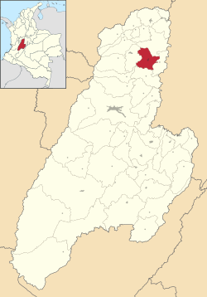

Half-breed with Chibchas
In 1.863 February 21st Lerida became municipality by law, its administration started in January 1st , 1864, its first mayor was Antonio Dorjuela.
In 1.874 coup against Tomas Cipriano de Mosquera, replaced by Santos Acosta. Tolima rose up in arms supported by the Ambalema’s snake (la culebra de Ambalema) a seditious group that operated in the region commanded by Eugenio Castillo.
In 1,869 was the largest tobacco exportation in the country, this is produced in the whole area but is collected in Ambalema, for this period the tobacco factories weren’t established.
In 1.870 Isidoro Parra founded Libano and coffee is carried to the The Colombian coffee Region “coffee axis”also to Icononzo, Carmen de Apicala and the South of department of Tolima.
In 1.876 the tobacco production entered a crisis, the prosperity ended, and towns as Lerida are abandoned, its territories became pastures, the solitude reigns.
Causes are many: high taxes, low salaries, import of sumptuary goods, human staff wasn’t trained, transport system was in bad conditions, and the competitiveness was strong against and Java and Sumatra.

