Homework
Topic: First contact
- Match as appropriate
- Hello | 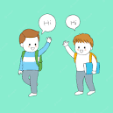  you.
- Nice | Are you.
- How | To meet.
- Good | bro.
- Thank | morning.
- Fill in the graps.
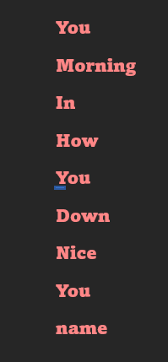
- Good morning
- Good ……… everyone
- How are ……..?
- Fine, thanks. ……… are you?
- Gread.
- Come …….., please.
- Nice to meet ……..
- My……. Is kate.
- Sit……., please
- Thank.

