Name……………
Date: …………...
Personal Presentation
Part A:
With the following word box complete the following information about a personal presentation

27 – Alicia – brother – Barcelona – dancing – time – Spanish - work

Hello, I’m _____ and I’m ____ years old. I’m ________, I live in _________ with my parents and my _______, I have a little cat, I ______ in a travel agency as a business analyst. I like _________ and swimming in my free _______. What I like the most is to walk around in the countryside. I really hate to get up late, because I think it’s better not to waste time!
Part B:
- Then record an audio in which you build your own personal presentation
- you should paste the audio link into the document
- to build your personal presentation answer the following questions:
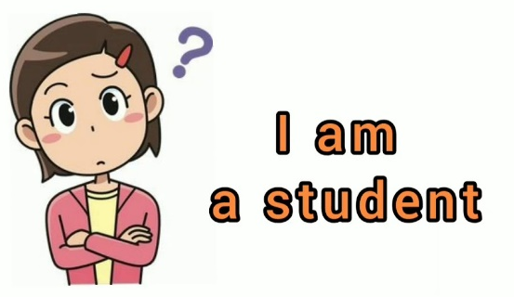
- What is your nationality?
- How old are you?
- With whom you live?
- Do you like animals?

