Homework
Complete.
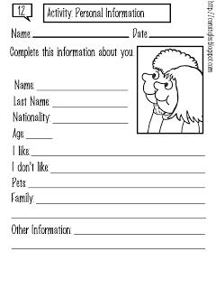

2. personal information
- recorder the words
Example: is / your / name / what / ?
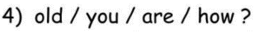
what is your name

 
 


