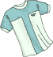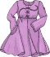

SKIRT – DRESS – T-SHIRT – HAT
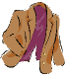

TIE – JEANS – SUIT - COAT

