THE LAST PANCHE RESISTANCE
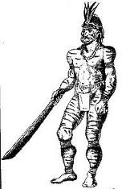
In 1.537, the Spanish arrived to Guacheta, Funza and Tibacuy. In November of 1.538, the Spaniard conqueror Sebastian de Belalcázar discovered the fields where centuries later Lerida was founded, he conquered this territory.
In 1.539 before the Jimenez de Quesada trip to Spain, he kept friendly contacts with Sagipa, an indigenous Chibcha chief to collaborate with the Panche defeat.
Guataqui is the first Panche town to be taken; this is a port of shipment on the Magdalena River.
In this period The Panche gave a hard blow, military and morally to the Spaniards, this cause a big sorrow to the Spanish army, some converted mestizos killed the captain Jeronimo Hurtado, nephew of Jimenez de Quesada.
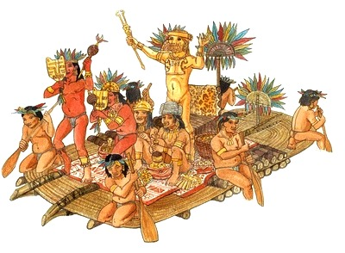
The panche adopted the ambush like combat method, then the politics unit or alliances between Indian Chiefs appear. The last Panche Indian chiefs were twelve who make up the resistance in the North of the department of Tolima in front of European colonization. The Panche living in the center of the Country are ferocious, combatant and free until death.
- Guacana: Governor of Tocaima in 1544, he is powerful and respected.
- Lachimi: He is taken prisoner and killed after being defeated in a bloody battle.
- Calandaima: Chief of Anapoima, who is subjugated.
- Conchima: He disappeared from sight of his people.
- Iqueima: His territories are in Fusagasuga, he is defeated in a surprise attack.
- Yuldama: Lord of the North of Tolima, he was a brave leader of Marquetones Gualies and other small groups , he is killed in combat for the ferocious Spanish army.
- Pompomá: Main ally of the Gualies, his inheritor was kidnap by Jimenez de Quesada to defeated Pompomá.
- Cirircua: son of Yuldama, he was proud an brave, he fight the Spaniards until the end, his will is broken, hopeless he obeys the Spanish oppression.
- Guastia: He rules near Bogota.
- Niquiatepa: he was ally with the Gualies, he defends his people from slavery, he rules around Guayabal, (Tolima), he turned himself in to the Spanish and is chained.
- Cimarra: he cooperates and is obedient with the regime; nevertheless he decides to fight the empire that practices a double moral, so the Spanish only want the Indian extinction.
- Ondama: Lord of Honda, skillful and zealous, he fights to free his people. He is defeated and subdued, his territories were falling slowly.

