Activity 3
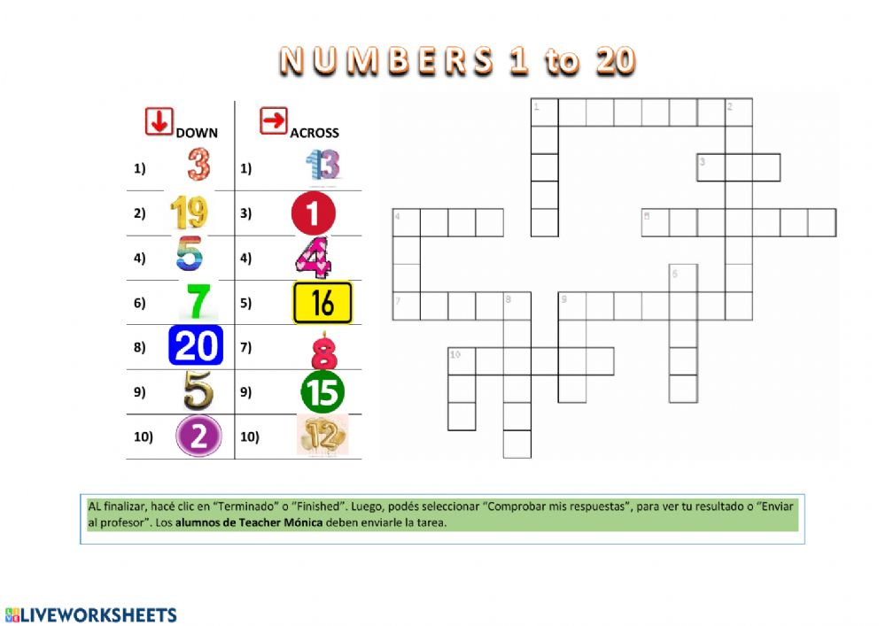
Complete the crossword.

